# *Chapter Three Hands-On-Assignments*

1. Delete the table category

Cut and paste your SQL Statements that you used to create your tables here:

***drop table category;***

Attach screen shots of your table data here.

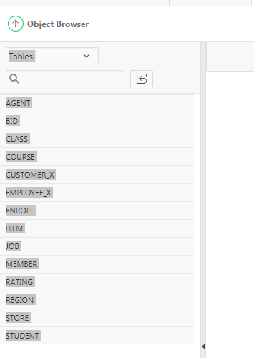

1. Create a new table containing these two columns: CID and CNAME. The table name should be Category. The CNAME column should be able to store character strings up to a maximum length of 120. The CID column contains a numeric ID and should allow a 2-digit number.

Cut and paste your SQL Statements that you used to create your tables here:

***create table category(CID number (2,0), CNAME varchar(120));***

Attach screen shots of your table data here.

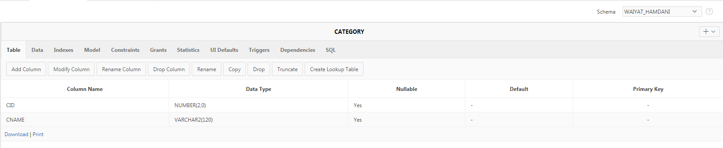

1. Add the following data to the table Category:

|  |  |
| --- | --- |
| ***CID*** | ***CNAME*** |
| 11 | ('Books:Biology'); |
| 12 | ('Books:Computers'); |
| 13 | ('Books:Economics'); |
| 14 | ('Books:Fiction'); |
| 15 | ('Computers:Apple:Desktops'); |
| 16 | ('Computers:Apple:Laptops'); |
| 17 | ('Computers:PCs:Desktops'); |
| 18 | ('Computers:PCs:Laptops'); |
| 19 | ('Computers:Storage:Hard Drives'); |
| 20 | ('Computers:Storage:Flash Drives'); |
| 21 | ('DVDs:Action'); |
| 22 | ('DVDs:Comedy'); |
| 23 | ('Music:Blues'); |
| 24 | ('Music:Jazz'); |
| 25 | ('Music:World'); |
| 26 | ('Video Games:Systems:XBox 360'); |
| 28 | ('Video Games:Systems:Playstation'); |
| 29 | ('Video Games:Systems:Nintendo DS'); |
| 30 | ('Video Games:Games:XBox 360'); |
| 31 | ('Video Games:Games:Wii'); |
| 32 | ('Video Games:Games:Playstation'); |
| 33 | ('Video Games:Games:Nintendo DS'); |

Cut and paste your SQL Statements that you used to create your tables here:

***INSERT INTO category (CID,CNAME)VALUES ( 11 , 'Books:Biology');***

***INSERT INTO category (CID,CNAME)VALUES ( 12 , 'Books:Computers');***

***INSERT INTO category(CID,CNAME)VALUES ( 13 , 'Books:Economics');***

***INSERT INTO category (CID,CNAME)VALUES ( 14 , 'Books:Fiction');***

***INSERT INTO category (CID,CNAME)VALUES ( 15 , 'Computers:Apple:Desktops');***

***INSERT INTO category (CID,CNAME)VALUES ( 16 , 'Computers:Apple:Laptops');***

***INSERT INTO category (CID,CNAME)VALUES ( 17 , 'Computers:PCs:Desktops');***

***INSERT INTO category (CID,CNAME)VALUES ( 18 , 'Computers:PCs:Laptops');***

***INSERT INTO category (CID,CNAME)VALUES ( 19 , 'Computers:Storage:Hard Drives');***

***INSERT INTO category (CID,CNAME)VALUES ( 20 , 'Computers:Storage:Flash Drives');***

***INSERT INTO category (CID,CNAME)VALUES ( 21 , 'DVDs:Action');***

***INSERT INTO category (CID,CNAME)VALUES ( 22 , 'DVDs:Comedy');***

***INSERT INTO category (CID,CNAME)VALUES ( 23 , 'Music:Blues');***

***INSERT INTO category (CID,CNAME)VALUES ( 24 , 'Music:Jazz');***

***INSERT INTO category (CID,CNAME)VALUES ( 25 , 'Music:World');***

***INSERT INTO category (CID,CNAME)VALUES ( 26 , 'Video Games:Systems:XBox 360');***

***INSERT INTO category (CID,CNAME)VALUES ( 28 , 'Video Games:Systems:Playstation');***

***INSERT INTO category (CID,CNAME)VALUES ( 29 , 'Video Games:Systems:Nintendo DS');***

***INSERT INTO category (CID,CNAME)VALUES ( 30 , 'Video Games:Games:XBox 360');***

***INSERT INTO Category (CID,CNAME)VALUES ( 31 , 'Video Games:Games:Wii');***

***INSERT INTO category (CID,CNAME)VALUES ( 32 , 'Video Games:Games:Playstation');***

***INSERT INTO category (CID,CNAME)VALUES ( 33 , 'Video Games:Games:Nintendo DS');***

Attach screen shots of your table data here.

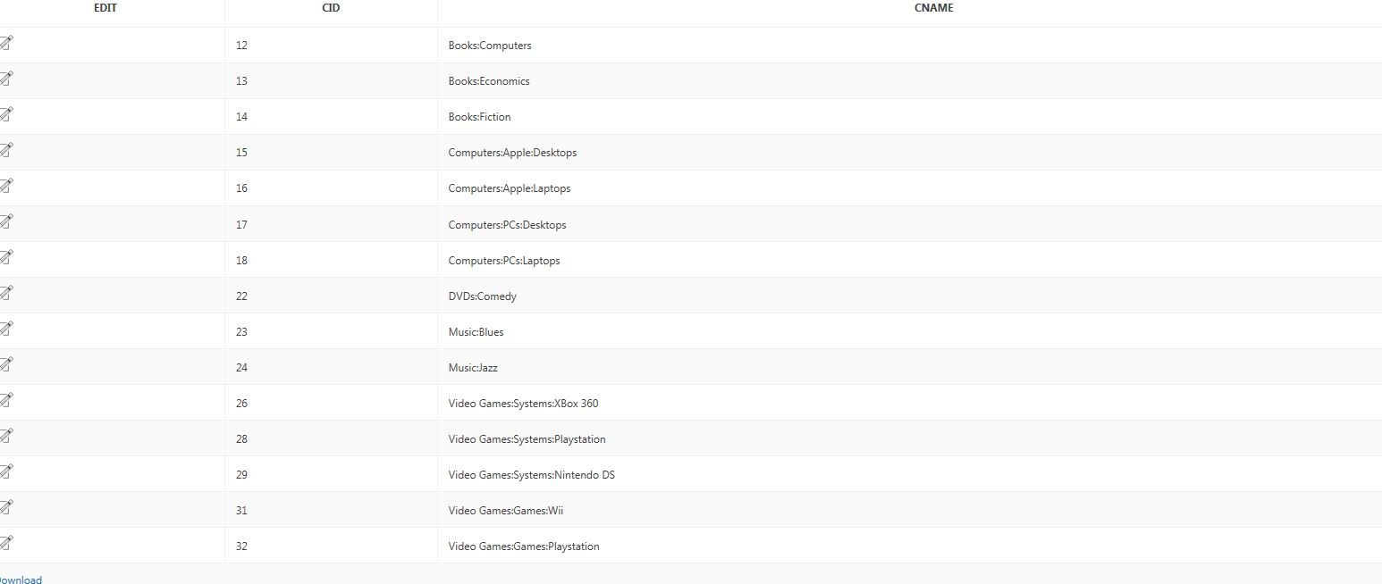

1. Add a column named CID to the table ITEM. The CID column should contains a numeric ID and should allow a 2-digit number.

Cut and paste your SQL Statements that you used to create your tables here:

***alter table ITEM add CID number(2,0);***

Attach screen shots of your table data here.

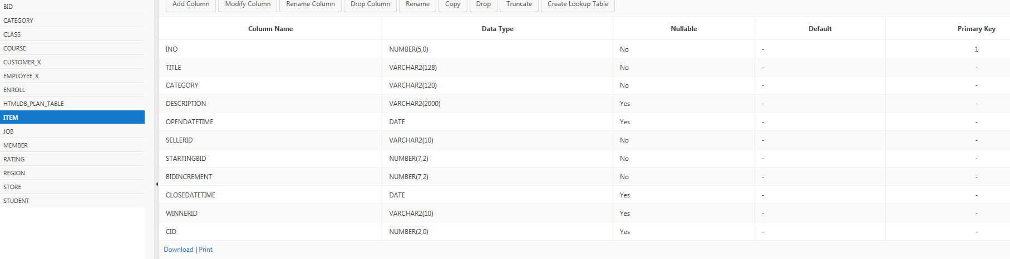

NOTE: Before you complete step 5 you need to upload and run the SQL scripts *“Procedure To Add CID to Item Table.sql”* and “*Procedure To Test Add CID to Item Table.sql*” IN THAT ORDER from the Chapter Three Table Creation and Management folder in Blackboard Learn.

Then run the SQL command:

***BEGIN***

***test();***

***END;***

1. Delete the column Category from the table ITEM.

Cut and paste your SQL Statements that you used to create your tables here:

***alter table ITEM drop column category;***

Attach screen shots of your table data here.

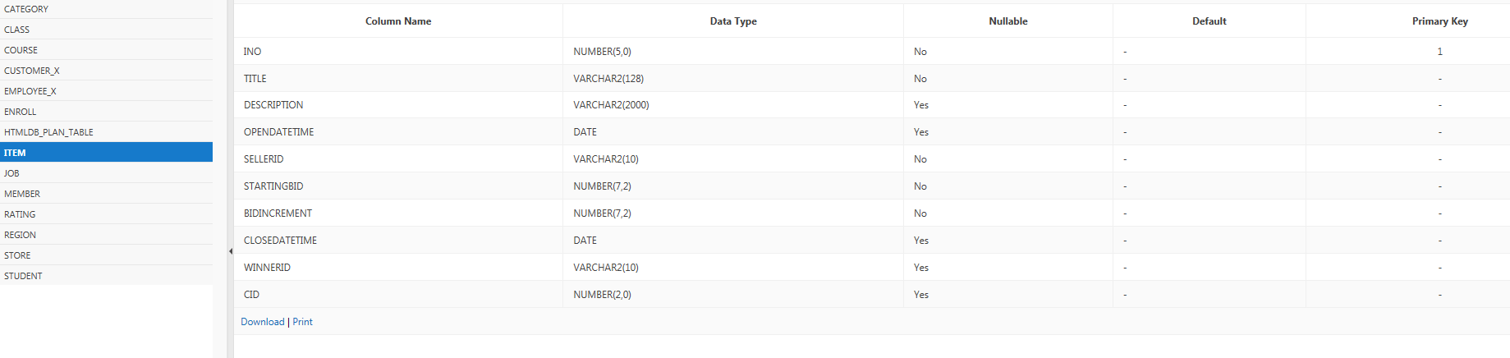

1. Mark the BUYERRATING column of the RATING table as unused.

Cut and paste your SQL Statements that you used to create your tables here:

***alter table RATING set unused column BUYERRATING;***

Attach screen shots of your table data here.

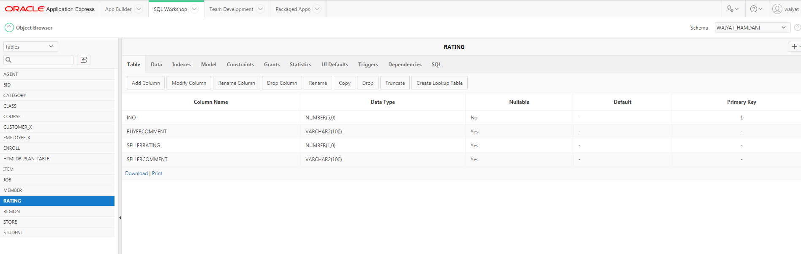

1. Delete the RATING table permanently.

Cut and paste your SQL Statements that you used to create your tables here:

***drop table RATING purge;***

Attach screen shots of your table data here.

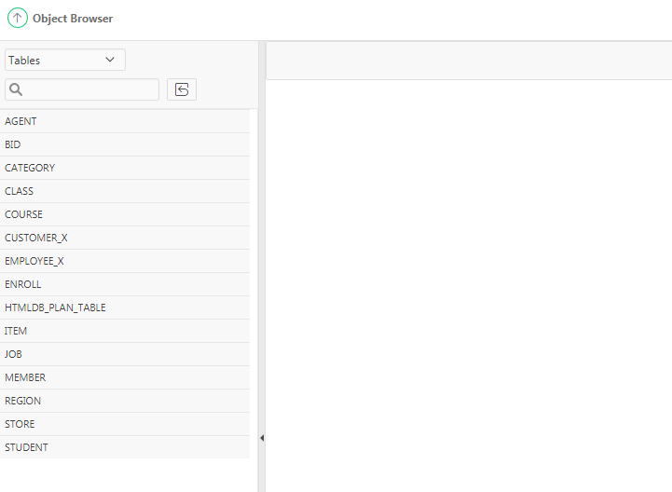

1. Rename the BID table as BIDS.

Cut and paste your SQL Statements that you used to create your tables here:

***rename bid to bids;***

Attach screen shots of your table data here.

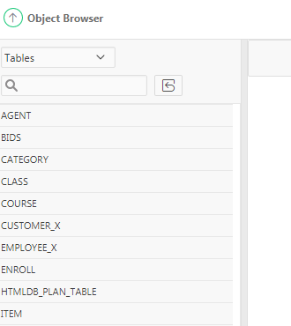

1. Modify the TIMEOFBID column of the new BIDS table so that the system date is the default date.

Cut and paste your SQL Statements that you used to create your tables here:

***ALTER TABLE BIDS MODIFY (TIMEOFBID date default sysdate);***

Attach screen shots of your table data here.

